- Project Title : Implement Image Edge Detection using Convolutional Neural Network(CNN) Layers with Tensorflow
- Your Name : Preeti Maheshgouda Patil
- Course & Semester : BCA,6th sem
- College Name : KLE'S BK BCA College Chikodi
- University Name : Rani Chennamma University
- Academic Year : 2026
- Guide’s Name : Mr.Naresh N

- Objective:
To build and train a Convolutional Neural Network (CNN) using TensorFlow to classify images.
- Code:
#Implement Image Edge Detection using Convolutional Neural Network(CNN) layers with tensorflow.
import numpy as np
import tensorflow as tf
import matplotlib.pyplot as plt
from itertools import product

#set the param
plt.rc('figure',autolayout=True)
plt.rc('image',cmap='magma')

#define the kernel
kernel=tf.constant([[-1,-1,-1],[-1,8,-1],[-1,-1,-1],])

#Load the image
image=tf.io.read_file('IMAGE.jpg')
image=tf.io.decode_jpeg(image,channels=1)
image=tf.image.resize(image,size=[300,300])

#Plot the image
img=tf.squeeze(image).numpy()
plt.figure(figsize=(5,5))
plt.imshow(img,cmap='gray')
plt.axis('off')
plt.title('Original Gray Scale image')
plt.show();

#Reformat
image=tf.image.convert_image_dtype(image,dtype=tf.float32)
image=tf.expand_dims(image,axis=0)
kernel=tf.reshape(kernel,[*kernel.shape,1,1])
kernel=tf.cast(kernel,dtype=tf.float32)

#Convolution Layer
conv_fn=tf.nn.conv2d
image_filter=conv_fn(input=image,filters=kernel,strides=1,padding='SAME')
plt.figure(figsize=(15,5))

#Plot the convolved image
plt.subplot(1,3,1)
plt.imshow(tf.squeeze(image_filter))
plt.axis('off')
plt.title('Convolution')

#activation Layer
relu_fn=tf.nn.relu

#Image detection
image_detect=relu_fn(image_filter)
plt.subplot(1,3,2)
plt.imshow(tf.squeeze(image_detect))
plt.axis('off')
plt.title('Activation')

#Pooling Layer(Fixed)
image_condense=tf.nn.pool(
input=image_detect,
window_shape=(2,2),
pooling_type='MAX',
strides=(2,2),
padding='SAME')

#Display All Results
plt.figure(figsize=(15,5))
plt.subplot(1,3,1)
plt.imshow(tf.squeeze(image_filter),cmap='gray')
plt.title('Convolution Output')
plt.axis('off')

plt.subplot(1,3,2)
plt.imshow(tf.squeeze(image_detect),cmap='gray')
plt.title('ReLU Activation')
plt.axis('off')

plt.subplot(1,3,3)
plt.imshow(tf.squeeze(image_condense),cmap='gray')
plt.title('Max Pooling Output')
plt.axis('off')
plt.show()

Output: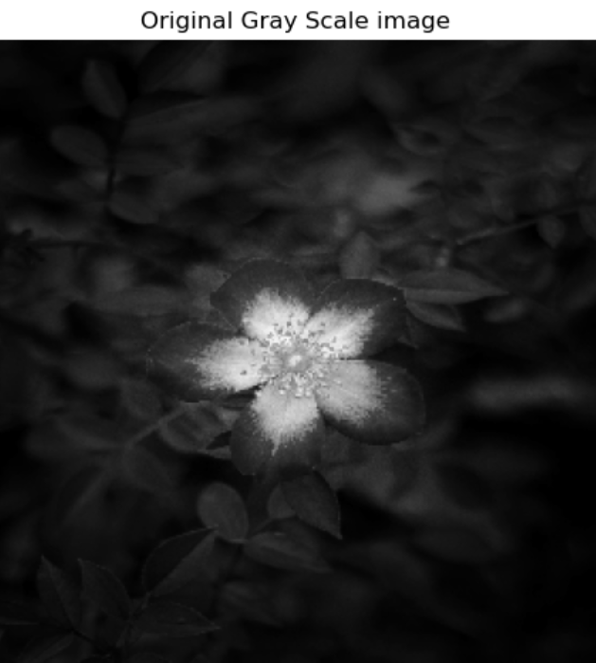
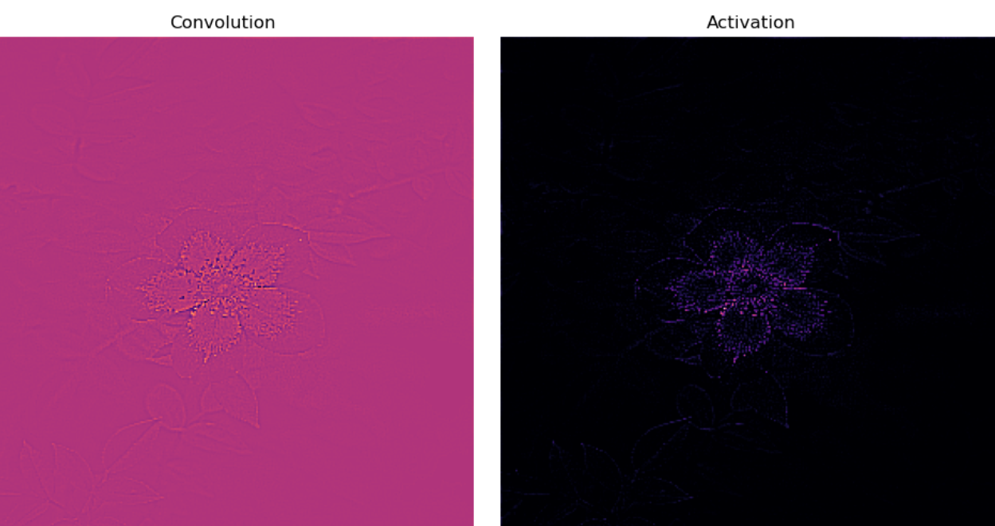
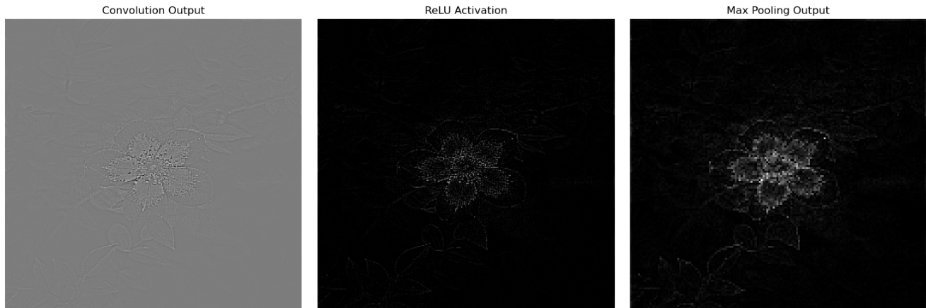
- Description:
In this project, a CNN model was developed using TensorFlow and Keras. The model uses convolutional layers to automatically extract features from input images, followed by pooling and fully connected layers for classification. The dataset images were resized and normalized before training.
The TensorFlow framework was used to design, train, and evaluate the CNN model. The model was trained on a labeled dataset and tested on unseen images to measure its performance.
- Result:
The CNN achieved good accuracy and was able to correctly classify most of the test images.
- Advantages of CNNs
1. Good at detecting patterns and features in images, videos, and audio signals.
2. Robust to translation, rotation, and scaling invariance.
3. End-to-end training, no need for manual feature extraction.
4. Can handle large amounts of data and achieve high accuracy.
- Disadvantages of CNNs
1. Computationally expensive to train and require a lot of memory.
2. Can be prone to overfitting if not enough data or proper regularization is used.
3. Requires large amounts of labeled data.
4. Interpretability is limited, it's hard to understand what the network has learned.
- Conclusion:
TensorFlow makes it easy to implement CNN models efficiently, and the trained CNN proved effective for image classification tasks.

